**Do I Need a Database?**

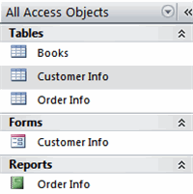Access 2007 is a program that allows you to **create** and **manage** databases. A **database** is a place where you can **store information** related to a specific topic. How you intend to use the information will determine whether you need an Access database or a different program to create and manage your data.   
  
In this lesson, we will discuss what a **database** can be used for, and how to decide whether you need a database to manage your information.

### Do I Need a Database?

##### What is a Database?

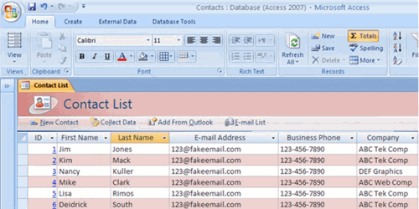A **database** allows you to store information related to a specific topic in an organized way. In addition to storing data, you can also **sort**, **extract**, and **summarize** information related to the data. One of the software programs that allow you to do this is **Microsoft Office Access 2007**, which is a database creation and management program.

Access 2007 Example

There are many types of data you may need to store and manage. For example, if you work for a business you might have a **customer address list** to keep track of your customers and their orders. Or perhaps you need to track the amount each salesperson in the company sells each quarter.

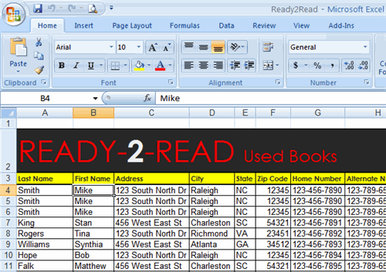Many people use **Microsoft Excel** to store and manage this type of data; however, Excel is a **spreadsheet software** program that is traditionally used to **manage numerical information**. While it can do an adequate job at storing some types of text data, that is not what the software was designed to do. So, how do you know which data can be managed with Excel and which data Access would manage more efficiently?

Sample Data in Excel 2007 Spreadsheet

Think about the **amount of data** you have to store and manage, and **what you want to do** with the data.

### Excel Example: Customer List and Order Tracking

##### Sorting and Filtering to Locate Data in Excel

In Excel, you can **easily store** your data in a **worksheet** so that you can mail promotional information to the entire list, or **sort or filter** to find specific customers. With a spreadsheet program, you can **filter** the customer information to display all the customers that live in a particular state or **sort** the data to **order** it in a particular way; however, if you want to see how many orders a customer placed in a year, **Excel can't efficiently** provide you with that data.

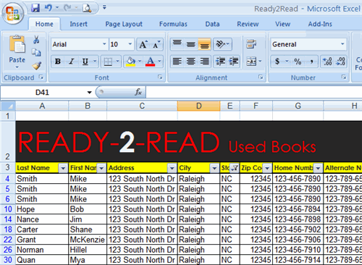

Data Filtered to Display NC State Records

##### Data Entry in Excel

If you use an Excel spreadsheet to track your orders, each time a customer places an order, you would have to enter a new row of information in the spreadsheet. This would likely include the customer's information including name and address. If a customer orders from your company more than once, the spreadsheet would contain **redundant** information.

As you can see, customers **Tonya Bullock** and **McKenzie Grant** placed multiple orders with the company on different days and for different books. The customer contact information was entered each time in the spreadsheet. This is the limitation of spreadsheet software such as Excel because it is a single, flat file.

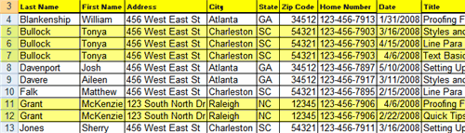

Data Sorted By Customer in an Excel Spreadsheet

### Access Example: Customer List and Order Tracking

##### Data Entry in Access

Access is intended to be used to manage information like the data described in this example. If you were working with an Access database, each time someone placed an order they would provide their name, street address, and phone number. Instead of entering this information each time they call to place an order, you would only **enter it once**.

The information would be entered into an Access **table** designed to contain the basic customer information. A table is a list of related information in columns and rows. In a table, each **row** is called a **record** and each **column** is called a **field**. An Access table in datasheet view looks similar to an Excel spreadsheet.

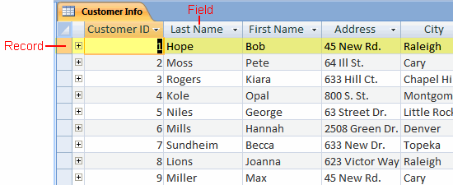

Data in an Access Customer Info Table

In addition to the table with customer information, you could also create a table with information about the products the company sells, and a third table to hold data related to specific orders.

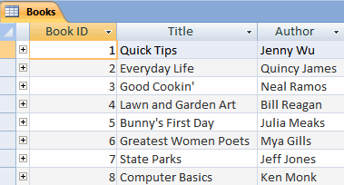

Data in an Access Books Table

##### Why Access Is More Efficient Than Excel

Access is a **relational database management** program, which means that the tables are are **related**, or linked, so that you can search each table individually, or retrieve information from multiple tables at the same time. You can do this because there are relationships established between the tables.

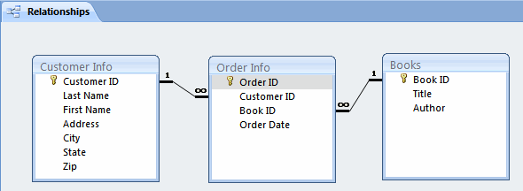

Table Relationships Diagram in Access

For example, you can identify the book that was most popular in a specific state. This is possible because you can **search and retrieve information from multiple tables** at the same time.   
  
The Customer Info table contains information about the states, and the Order table includes information about which books were ordered. You need information from **both tables** to identify the book that was most popular in a specific state. If you look at the information in these tables separately, you can see all the customer contact information and view a list of all the books in the store, but the real power comes in being able to link and extract information from multiple tables.

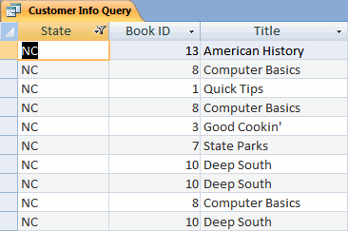

Search Results

### Exploring a Database

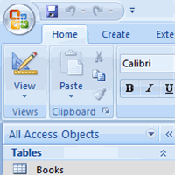Once you have determined that an Access database will help you store and manage your data, you will need to learn the **parts of a database**, how to **start using** Access, and how to **navigate the Access window**. In this lesson, we will discuss a basic overview of Access, including the parts of a database, and common tasks you can complete using a database.

### Exploring a Database

##### Databases in Our Lives

Think about all the information we encounter on a typical day that might be **organized by a database**. For example, if you go shopping at a department store for a toaster, the **store inventory** of products is information that has to be stored somewhere, along with the price of each product.   
  
When you make a purchase, the store needs to be able to store the sales information to determine the daily sales total and how track the decrease in inventory. A **database** could store this information, and also allow the store to quickly determine how many Brand X toasters are inventory without needing to count the inventory on the shelves.

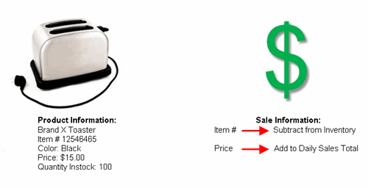

Real World Example

While this information could be managed without a database, it would be easier and more efficient to use one. Databases have an enormous impact in almost every area of our lives.

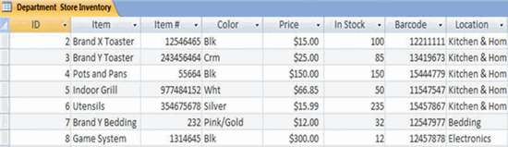Inventory in Access Database

##### Think About It

Think about what is going on around you in **everyday situations** and whether there might be a database at work.

* **Grocery Store**: The grocery store is stocked with items. The items have to be ordered, shipped, and stocked in the store. The store has to pay for the items. Then, when the customer buys the items, the cash register retrieves prices and the customer pays for products. Where databases might be involved in the situation?
* **Restaurant**: Where does the food come from? How does management know when to reorder a product? How are bills paid?
* **Traffic Lights**: Who or what controls when the lights turn red or green?

A database **maintains order and structure** in our lives. Databases are created using programs such as Microsoft Office Access 2007, which is a relational database program.

**Getting Started with Access**

When you start Access 2007, you will see the **Getting Started** window.

In the left pane, the **template categories** including the featured local templates are listed, as well as the categories on Office Online. Templates are **pre-built databases** focused on a specific task that you can download and use immediately.

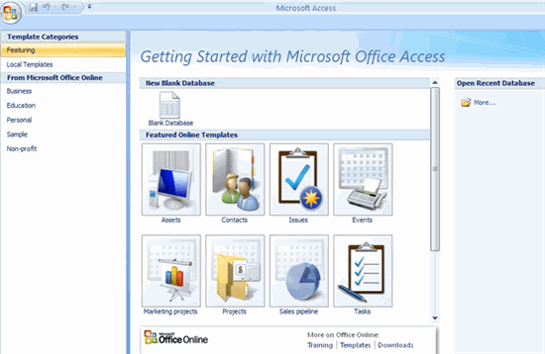

Getting Started Window

In the example below, the **featured templates** are selected, and the template options are displayed in the center area of the screen. Featured templates include database template options that are available online, as well as templates available as part of the local version of Access.

Featured Templates

### Featured TemplatesOpening a Database

You have three main options on the Getting Started page. You can open a template database store locally or online, an existing database, or a blank database.

##### To View Templates Included with Access:

* Click **Local Templates** in the left pane. The center of the screen will change to display icons for the templates.
* Select an **icon** in the center of the screen. Details about the database template will appear on the right.

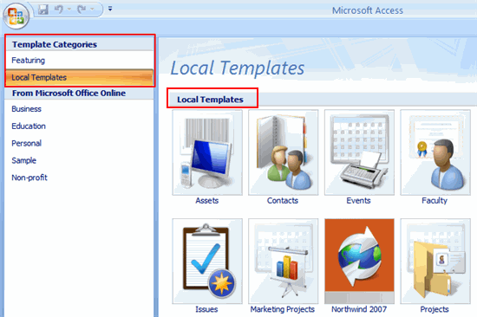Local Templates

In the left pane of the Getting Started window, you will see a list of categories for the templates available on Microsoft Office Online. You must have an Internet connection to download these database templates.

The Blank Database command allows you to create a database from scratch.

##### To Open an Existing Database:

* In the Open Recent Database section, double-click the file name of the database you wish to open. It will appear in the window.

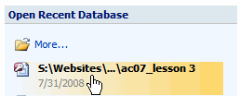Open Existing Database from List

OR

* Click the **More** link. A dialog box will appear.

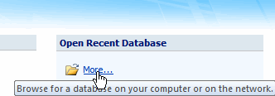Find Existing Database

* Select the database you wish to open.

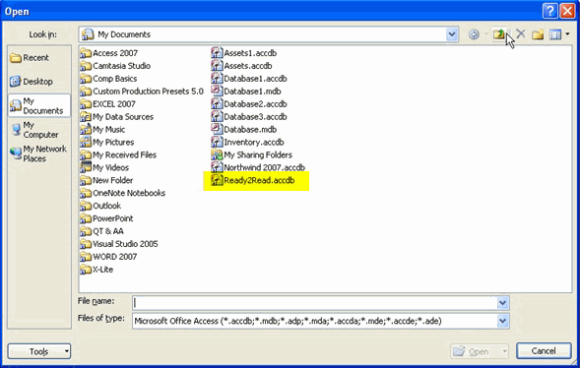Select Existing Database

* Click **Open**. The database will appear.

### The Access Window

Before you can begin to use a database, you need to become familiar with the Access window.

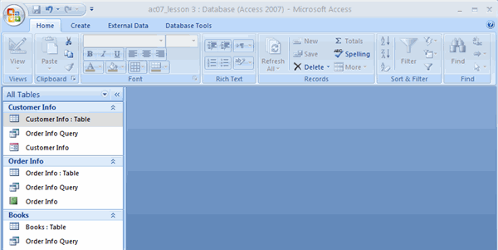Access Window

##### The Ribbon

Like other software in the Microsoft Office 2007 suite, Access 2007 has a **tabbed Ribbon system** that you use to navigate the database. The Ribbon is organized into **tabs**. Each tab contains **groups** of **commands** that you use to perform tasks in Access.   
  
For example, on the **Home** tab, you’ll see that there is a **Font** group that contains the **font formatting commands** such a font type, size, color, alignment, and more. Unless you use keyboard shortcuts for everything, the Ribbon is how you get the work done in Access.

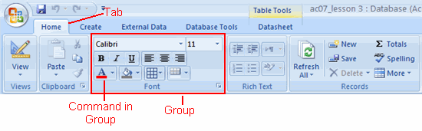Tabbed Ribbon

##### Quick Access Toolbar

Once you are familiar with Access, you may find that you there are commands that you use more often than others. To make it easier to use these commands, you can add them to the **Quick Access toolbar**. By default, the toolbar appears above the Ribbon on the left side of the Access window, and includes the Save, Undo, and Redo commands.

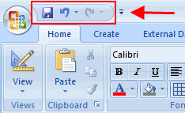Quick Access Toolbar

##### Microsoft Office Button

The **Microsoft Office Button** resides in the upper-left corner of the Access window and includes key menu options such as New, Save, Print, and more. It is also from this menu that you can change your Access Options.

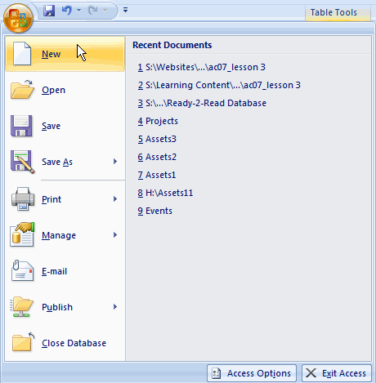Microsoft Office Button

##### Navigation Pane

The main control center of each Access database is the **Navigation Pane**. It shows you what is in the database and makes the information accessible to you. Also, you can choose to close the navigation pane, if you need more of the Access window to complete specific tasks.

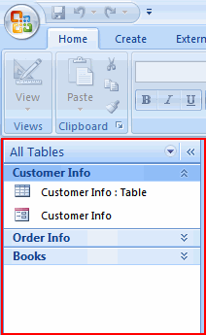Navigation Pane

##### To Open and Close the Navigation Pane:

* Click the **Shutter Bar Button** on the right side of the Navigation Pane .

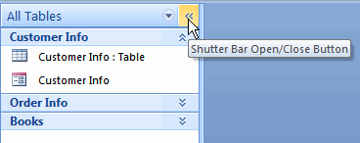Shutter Bar Button

* The Navigation Pane appears as a single column when it is collapsed.

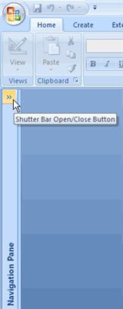Navigation Pane Closed

### Parts of a Database

A Microsoft Access database is made up of several components including **tables**, **forms**, **queries**, and **reports**. These components are called **database objects**. One or more of these objects are formed when a database is created, and all the objects appear in the Navigation Pane. To make the database easier to navigate, beginning Access users may want to reorder the objects in the Navigation Pane.

##### To Change how Objects are Ordered in the Navigation Pane:

* Click the drop-down arrow at the top of the Navigation Pane to see the ordering options.

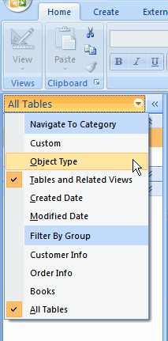Change Object Order in Navigation Pane

* Select a menu option. The Navigation Pane will appear reordered based on your selection.

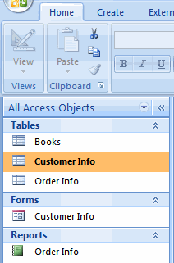Objects Reordered in Navigation Pane

If you are new to databases, arranging the **objects by type** in the Navigation Pane is usually a good idea. This will group tables, forms, queries, and reports in individual groups in the pane.

##### To Expand or Collapse a Group:

* Click any **downward** pointing double **arrow** to **expand** a group to display all the objects.
* Click any **upward** pointing double arrow to **collapse** a group to hide all the objects.

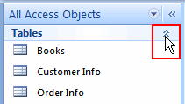Display Objects

### Parts of a Database (cont.)

##### Tables

A **table** is the database object that contains the basic information you wish to store. A blue and white icon represents the table in the Navigation Pane.

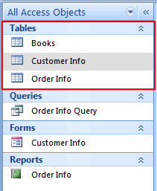Table Icon

In the Customer Info table below, there are **columns**, or **fields**, of information including first name, last name, and address. Each **row** is a **record** that contains the information specific to the fields listed.

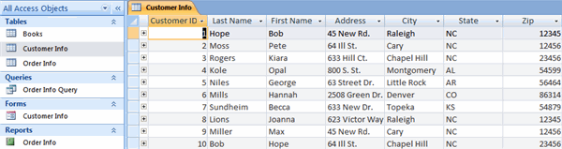Table

The goal when working with databases is to only **store information once** so that no redundant data exists. This means that in the example database, the customer information will only appear in the Customer Info table, and not in any other table.

##### Queries

Another database object is called a **query**. It is represented by a green and white stacked squares. A query allows you to **retrieve information** from one or more tables based on a set of **search conditions** you define using the table fields.

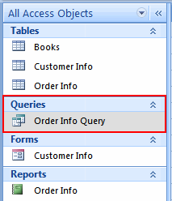Query Icon

For example, if you want to know the name of the books that have sold in Colorado and Kansas, you could create a query that would retrieve information from multiple tables to determine the answer. In this example, you would retrieve information from the Order table and Books table.

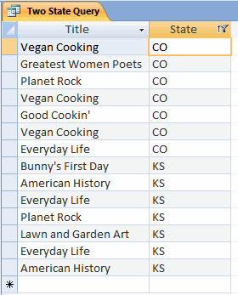Query

##### Forms

A third database object is the **form**, which is represented by a red and white icon. Forms are an Access tool that users can create to make **data entry** in database tables **easier**.

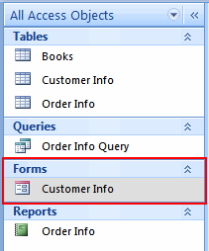Form Icon

Entering data directly into a table can be difficult if there is a lot of information to enter. Like an Excel spreadsheet, an Access table is essentially a screen filled with blank rows where a user enters records. **Forms**, however, provide users with an easy-to-read interface where they can **enter table data**. Forms are especially useful for Access users that aren’t comfortable working with databases.

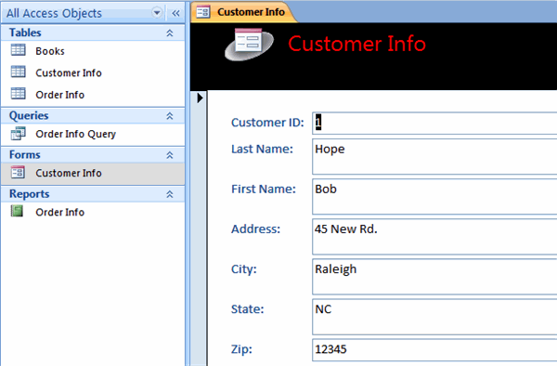Form

##### Reports

The final database object is the **report**, which is represented by a green icon.

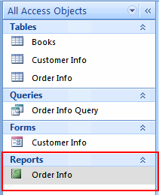Report Icon

A report is an effective way to **analyze and present data** using a specific layout. The text can be formatted in an Access report, just like it can be in Word documents.

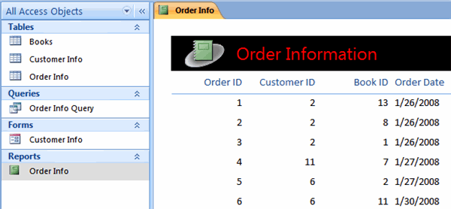Report

##### To Close an Object:

* Select the **tab** for the object you wish to close. (The highlighted tab is the active tab).
* Right-click the tab and select Close from the menu.

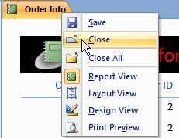Close Object

**Challenge!**

* What is a **table**?
* What is a **query**?
* What benefit do **forms** provide?

### Query Basics and the Query Wizard

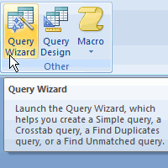The information in a database can be used to **answer questions**. You can retrieve and use information from Access database tables by creating a **query**. In this lesson, you will learn how to create a simple query using the Query Wizard.

### Query Basics and the Query Wizard

[Watch the video! (Part 1)](http://www.gcflearnfree.org/content/screencasts/shared/player_776x600.aspx?screenCast=ac07/ac07_queries_1) (4:11 min) [(Part 2)](http://www.gcflearnfree.org/content/screencasts/shared/player_776x600.aspx?screenCast=ac07/ac07_queries_2) (5:20 min) - [Tips](http://www.gcflearnfree.org/PopUps/VideoTips.aspx) for watching our videos.

Download the [example](http://www.gcflearnfree.org/content/downloads/ex07_Budget_lesson3.xlsx) to work along with the video.

##### To Open an Existing Database:

* Open Access 2007.
* In the **Open Recent Database** section, double-click the database you wish to open or click **More** to select a database that is not visible.

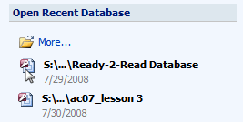Open Database

* Click **Options** and view the security warning.

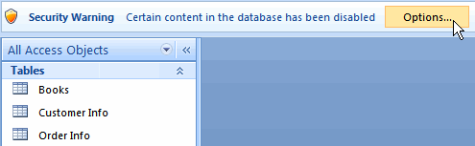Options Warning

* Select one of the options from the dialog box.
  + If the database is not from a trusted source, leave the default setting selected.
  + If the database is from a trusted source, you can choose to enable the content, if you wish.

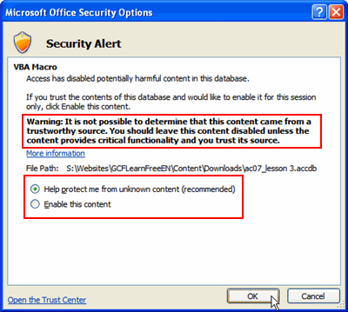Security Warning

* Click OK. The database will appear.

### Queries

Database tables contain information, but how do you get retrieve it in a useful way? Access allows you to locate and use information from multiple database tables by **creating a query**. A **query** is the **data that results** when you search the database for answers to specific questions.

##### Music Collection Example

Imagine you are working with a database that **organizes and manages** your entire **music collection**. You might want to know:

* Which songs do I have by a specific performer?
* Which genre of music do I own the most of?

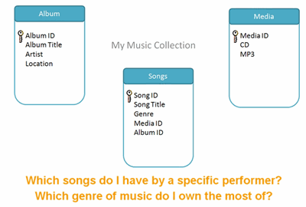Query Questions

You could use the information contained in the three tables to **create a query** that answers these questions.

### Queries (cont.)

##### Ready2Read Business Example

Meaningful queries are possible because you can create **relationships** between tables that allow data from one table to be linked to data in another table. This allows for more complex questions to be answered using the information contained in database tables.

Before you create a query, you may want to view the existing relationships to see the tables in the database, and the fields, or specific information, contained in each.

##### To Display the Table Relationships:

* Select the **Database Tools** tab.
* Click the **Relationship** command.

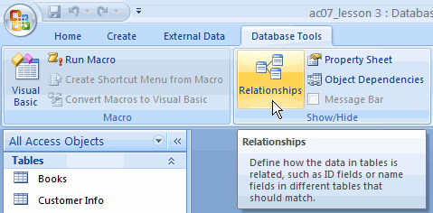Relationship Command

* The existing tables will appear on the screen. In this example, there are three tables. The lines connecting the tables represent the relationship.

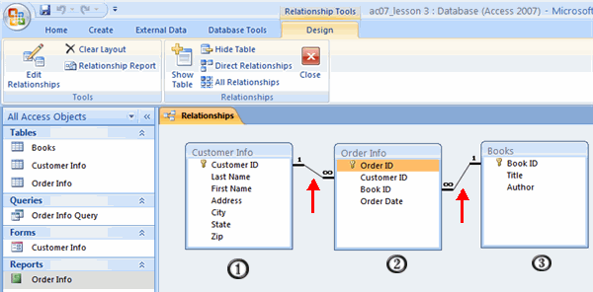Relationships

##### Query Questions in the Ready2Read Database

Quite simply, **better questions equal better queries**. Begin by asking a question that you wish to answer using the available data. Then, rephrase the question as a statement.

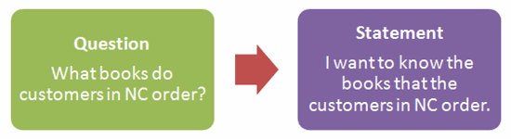Query Question and Statement for the Ready2Read Database

### Create a Query

Two commands that allow you to **create queries** are located in the **Other** group on the **Create** tab. The **Query Design** command allows you to create a new, blank query on your own from scratch. This is a more advanced concept that will be covered in a future lesson.

The **Query Wizard** command launches a wizard tool that will guide you through the process of creating a query. The wizard provides fewer options than a query created from scratch, but it is the easiest way to create a query if you are new to Access.

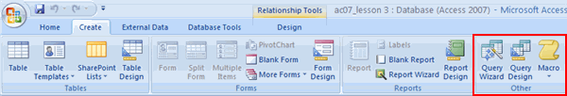Other Group

The following instructions explain how to create a query using the wizard and uses the Ready2Read database as the example. Each database will be different, but the wizard provides the appropriate prompts based on the database being used.

##### To Create a Query Using the Query Wizard:

* Select the Create tab.
* Click the **Query Wizard** command. The New Query dialog box will appear.

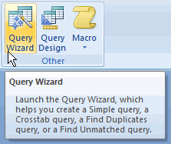Query Wizard

* Select **Simple Query Wizard** from the query types on the right side. As you select a query type, a description of the query will appear on the left side of the dialog box.

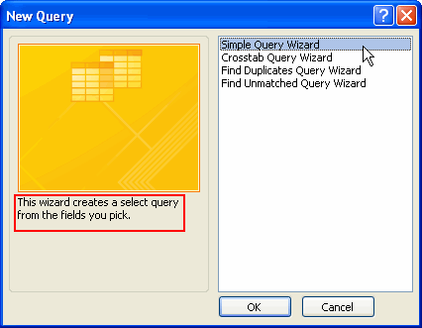Select Simple Query

* Click OK. The Simple Query Wizard will appear.

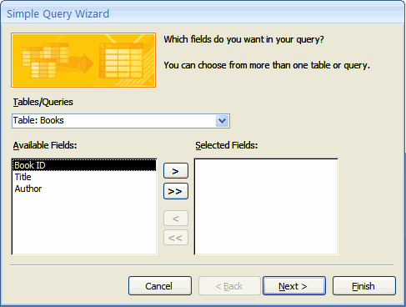Simple Query Wizard

* Determine the **question** you wish to answer with the data. In this example, the question is: **What books do customers in NC order?**
* The **Books table** is selected by default and the fields in the table appear in the Available Fields section. Ask yourself, "Which fields, if any, do I need from this table to answer the question?"
* Select any field needed from the Books table. In this example, we select Title.
* Click the **right arrow** to add the field to the query.

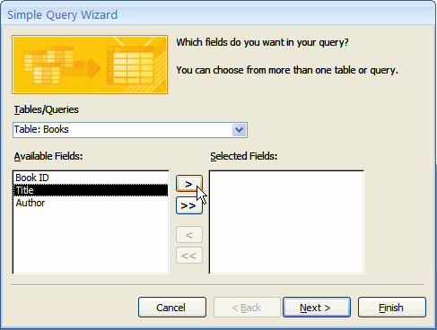Add Fields to Query

* Repeat until all the necessary fields are added. In this case, Title is the only necessary field.

To add all the fields in the query, click the right facing double arrow. To delete a field from the query, select it and click the left arrow.

* Select the next **table** that contains data that is needed for the query. In this example, we select the Customer Info table.

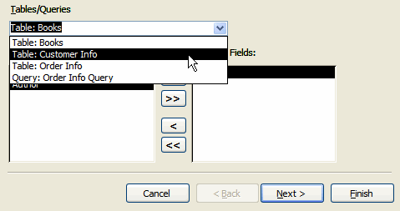Select Table

* Select any fields needed from the selected table.

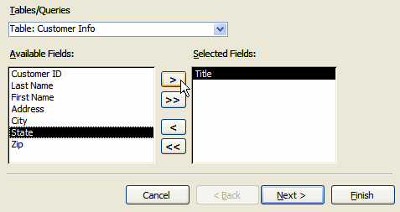Add Fields to Query

**Create a Query (cont.)**

* Click **Next** once all the fields that are necessary to answer the question have been entered.

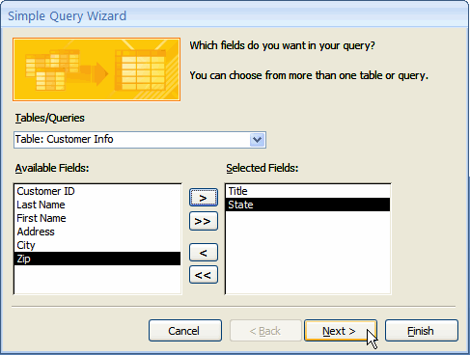Select all Necessary Fields

* Leave the default **Detailed** option selected and click **Next**.

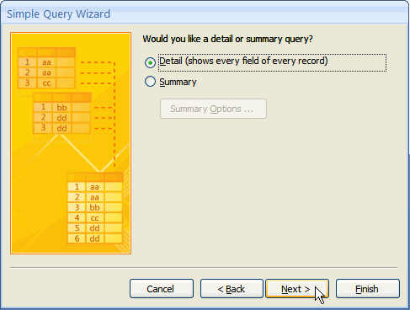Choose Detailed or Summary

* Enter a **title** for the query.
* Choose whether to **open** or **modify** the query. In this example, leave **Open** selected.

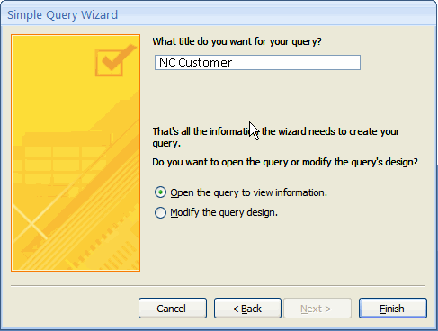Open or Modify Query

* Click **Finish**.
* The query will appear in the window and in the Navigation pane. The fields entered in the wizard will appear in the query.

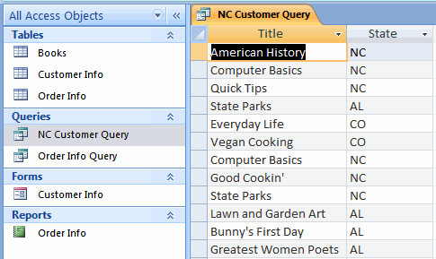NC Customer Query

### Basic Sorting and Filtering of Query Results

In the Query Wizard you can choose the fields for the query, but you can’t control the specific data in those fields from within the wizard. In the example, the query wizard produced a query that displayed the Book Title and the State information for each of the orders. To display only the book titles for the orders from the state of North Carolina, you will need to **filter** the data. **Filtering** the data **hides** it from view temporarily.

##### To Filter Query Results:

* Click the downward arrow in the heading of the column you want to filter. In this example, click State.
* Click **Select All** to clear all the options that are selected by default.

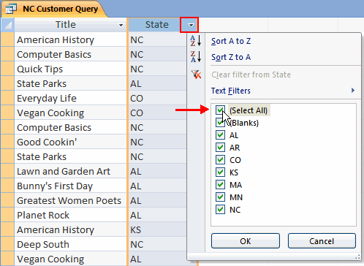Select Filter Option

* Select the item or items you wish to display. In this example, select NC.
* Click OK. The query results will appear filtered.

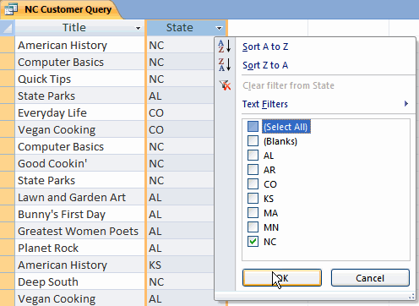Click OK to Filter

If you’re working with a large number of records, you may want to **sort** information in your query. Sorting **reorganizes** the information. In this example, you may want to sort the titles of the books so they appear in alphabetical order.

##### To Sort Query Results:

* Click the downward arrow in the column you want to sort. In this example, click Book.
* Select **Sort A to Z**. The titles will appear in alphabetical order.

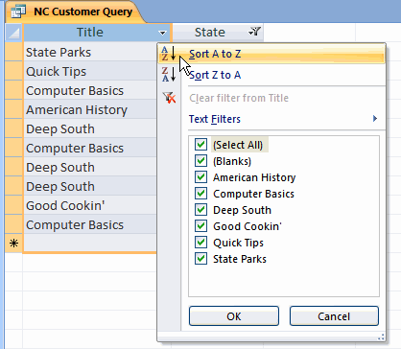Sort from A to Z

Sorting and filtering will be covered in more detail in a future lesson.

**Challenge!**

* Open the Ready2Read database.
* View the table relationships.
* Think of a question that can be answered by a query.
* Use the Query Wizard to create a query.

### Report Basics and the Report Wizard

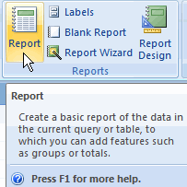**Reports** are one of the ways you can extract information from database tables. Access reports summarize and present data that is stored in tables in a meaningful and easy-to-read way. In this lesson, you will learn how to quickly generate a report with data from one table, and use the **report wizard** to create a report using data from multiple tables.

### Report Basics and the Report Wizard

[Watch the video!](http://www.gcflearnfree.org/content/screencasts/shared/player_776x600.aspx?screenCast=ac07/ac07_reports) (7:02 min) - [Tips](http://www.gcflearnfree.org/PopUps/VideoTips.aspx) for watching our videos.

Download the [example](http://www.gcflearnfree.org/content/downloads/ac07_lesson4.accdb) to work along with the video.

A common task when working with a database is **creating reports**. Reports in Access can look just like any report you create manually in Word; however, with Access you don’t enter the data directly into the report like you do with a Word document. Instead, the report is created using information you’ve already stored in your database tables. Reports **summarize database information** in a visually appealing format. Reports can be viewed on the computer or printed for ease of use.

##### To Create a Simple Report Using the Selected Table or Query:

* In the Navigation Pane, select the **table** or query that contains the data that you wish to include in the report.

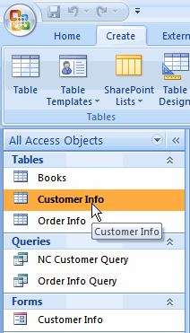Selected Table

* Select the Create tab.
* Click the **Report** command.

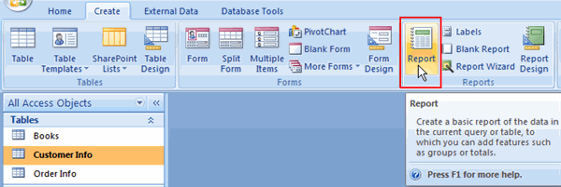Report Command

* Access will generate the report and it will appear in the window.

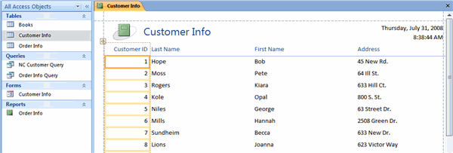Example Report

### The Report Wizard

If you want to have the ability to **select specific fields** for the report, the **Report Wizard** command gives you more control than the **Report** command. Also, the Report Wizard command allows you to use information from multiple tables in the report. Before you create a report, determine the **purpose of the report**. In this example, we want to create a report that includes the titles of the books that people in various states ordered.

##### To Create a Report Using the Report Wizard:

* Select the **Create** tab.
* Click the **Report Wizard** command. The Report Wizard will appear.

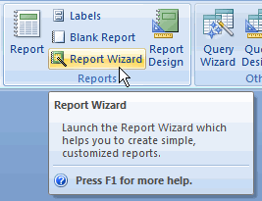Report Wizard

* Select the **query** or **table** that contains fields you want to use in the report. In this example, we select the Customer Info table.

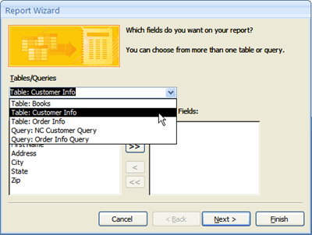Select Table in Report Wizard

* Select the **field** you want to add to the report.
* Click the **right arrow button** to add the field to the report.

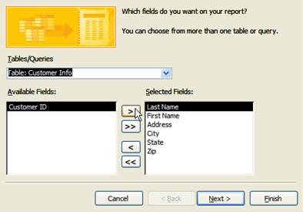Select Fields in Report Wizard

* Repeat until all necessary fields are added.

If you want to add all the fields, click the double right arrow. You can also click the left arrow button to remove a field from the selected list.

**The Report Wizard (cont.)**

* Click the drop-down arrow and **select** a different table or query. In this example, we select the Books table.
* Select the **field** that you want to include in the report.
* Click the **right arrow button** to add the field to the report.

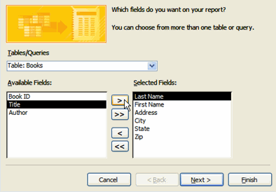Select Fields in Report Wizard

* Repeat until all necessary fields are added.
* Click **Next**.

The wizard will now list questions about how you want the information in the report to be displayed. Questions will vary based on the fields you included in the report.

* Select **by Books** or **by Customer Info**. In this example, we select **by Customer Info** so the report can be organized by state. As you switch between **by Books** and **by Customer Info**, the image on the right changes.

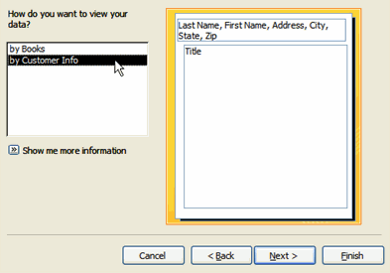Select Fields in Report Wizard

* Click **Next**.
* Select a **field** from the list, if you wish to **group** the report. In this example, we select **State**.
* Click the **right arrow** to add the field. The image will reflect the change.

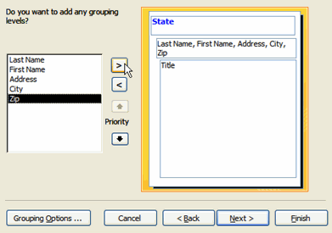Select Fields in Report Wizard

* Click **Next**.
* Select a **sort option** if you wish to sort the records in the report. In this example, we select Title.
* Click **Next**.

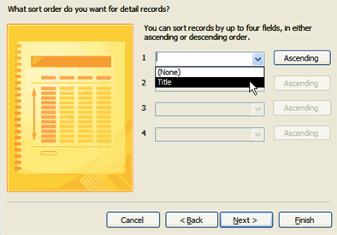Select Fields in Report Wizard

* Select a **Layout** and **Orientation** option. As you click each option, the image will reflect the change.
* Click **Next**.
* Select a **style**. As you click each option, the image will reflect the change.
* Click **Next**.
* Enter a name for the report.
* Click **Finish**. The report will open in Print Preview format.

**Challenge!**

* Open the Ready2Read database.
* Select the Books table.
* Create a report using the Report Command.
* Create a report using the Report Wizard.

### Working with Records

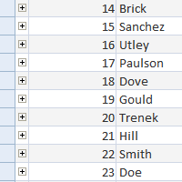Your database will only be useful if real data is stored in the tables. Each time you add a **new entry** to a table, you are entering a **new record**. In this lesson, you will learn how to enter a new record, as well as copy, paste, edit, and delete existing records.

### Working with Records

[Watch the video! (Part 1)](http://www.gcflearnfree.org/content/screencasts/shared/player_776x600.aspx?screenCast=ac07/ac07_records_1) (4:08 min) [(Part 2)](http://www.gcflearnfree.org/content/screencasts/shared/player_776x600.aspx?screenCast=ac07/ac07_records_2) (4:52 min) - [Tips](http://www.gcflearnfree.org/PopUps/VideoTips.aspx) for watching our videos.

Download the [example](http://www.gcflearnfree.org/content/downloads/ac07_lesson5.accdb) to work along with the video.

In addition to **entering new records** in a table, you will need to know how to copy and paste a record, edit and delete an existing record, and use Access commands to find a specific record. All of these are common tasks when working with an Access database.

Before you begin, it is important for you to understand how tables work. Each column in a table is called a **field**, and each **row** is called a **record**. The field that uniquely identifies the record is called the **primary key**.

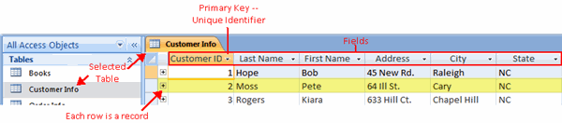Sample Table

##### To Open a Table:

* Double-click the **table** in the **Navigation Pane**.
* The table will appear in datasheet view, which is the default view.

The following tasks will use the **Customer Info** table in the Ready2Read database as a guide.

##### To Add a New Record:

* Locate the row with **New** in the **CustomerID** field.
* Place the insertion point in the **Last Name** field and enter the name. As you type, the number will appear in the CustomerID field.

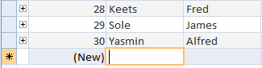Add New Record

* Press the **Tab** key to move to the next field.
* Enter information into the field.
* Repeat until all the necessary fields in the record are complete.

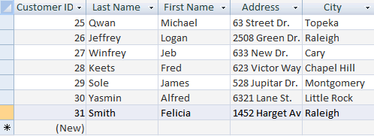Completed Record

##### To Copy a Record:

* Select the **record** you wish to copy. To do this, click the **blank square** to the left of the unique identifier in that record. A black arrow will appear.

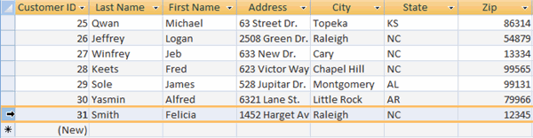Select Record to Copy

* Right-click and select **Copy** from the menu.

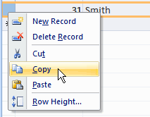Select Copy From Menu

The **Copy** command on the **Home** tab can also be used to copy a record.

### Working with Records (cont.)

##### To Paste a Record:

* **Select** the **row** where you wish to paste the record. To do this, click the **blank square** to the left of the unique identifier in the row. A black arrow will appear.

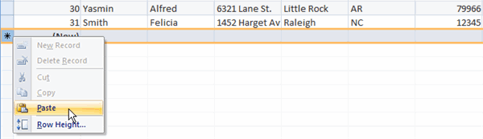Select Row

* Right-click and select **Paste** from the menu.

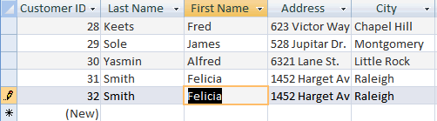Select Paste from Menu

* The record will appear in the selected row.

The **Paste** command on the **Home** tab can also be used to paste a record.

##### To Edit a Record:

* Select the **field** you want to **edit.**
* Make any necessary changes and save the table.

##### **To Save a Table:**

* Right-click the **tab** of any open table.
* Select **Save** from the menu.

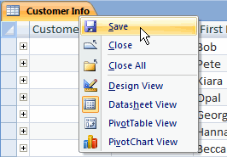Save Table

### Using Find and Replace

In addition to **adding** and **editing** records, you may need to **find a specific record** either to view the information or edit it. You can do this using the **Find** and **Replace** commands.

In the following example, we will search for a customer, Becca Sundaheim.

##### To Find a Record Using the Find Command:

* Place the **insertion point** in the field you want to search. In this example, the **Last Name** field.
* Click the **Find** command on the Home tab. The dialog box will appear.

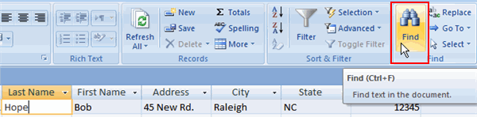Find Command

* Enter the **last name** in the field.
* Select the **area to search** in the **Look in** field. In this example, we select the Last Name field.

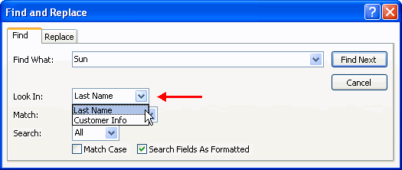Find Dialog Box: Area to Search

* Select the **area to match** in the **Match** field. If you are not sure you spelled the entry correctly, select Any Part of Field.

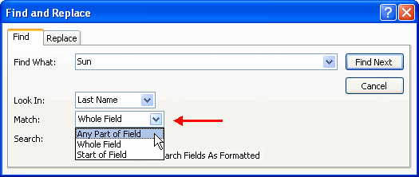Find Dialog Box: Area to Match

* Click **Find** in the dialog box. Access will highlight the first field that meets the criteria.

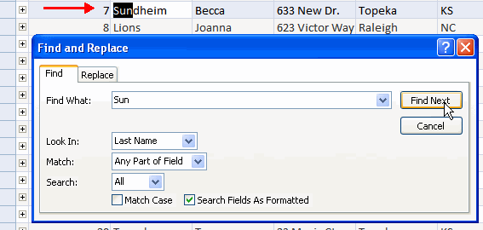Field Selected

* Close the dialog box or click **Find Next** to locate other entries.

In the following example, we will locate a customer, Kelly Smith. Her record needs to be updated to include her new last name.

##### To Edit a Record Using Find and Replace:

* Place the insertion point in the field you want to search. In this example, we select the Last Name field.
* Click the **Replace** command on the Home tab. The dialog box will appear.

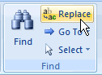Replace Command

* Enter the last name in the **Find** field.
* Enter the new last name in the **Replace** field.
* Select the **area to search** in the **Look in** field. In this example, we select the Last Name field.
* Select the **area to match** in the **Match** field. If you are not sure you spelled the entry correctly, select Any Part of Field.

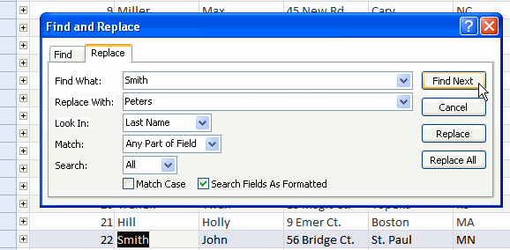Replace Word

* Click the **Find** command in the dialog box. Access will highlight the first field that meets the criteria.
* Click **Replace** if the correct entry is highlighted. If not, click **Find Next** until you locate the desired entry.
* Close the dialog box or click **Find Next** to locate other entries.

##### To Delete a Record:

* Select the record you wish to delete.
* Right-click and choose **Delete Record** from the menu.
* Select **Yes** to confirm you wish to delete the record.

You cannot delete records from one table if there are other tables that use the record.

**Challenge!**

* Open Access and create a table.
* Add 5 records.
* Edit a record.
* Delete a record.
* Copy and paste a record.
* Practice using the Find and Replace commands.